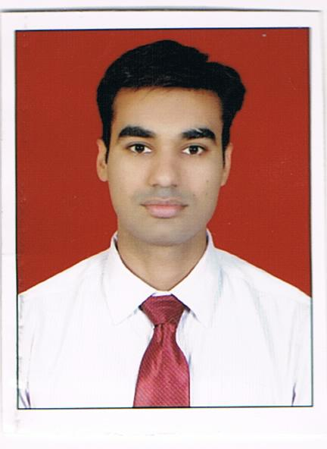

**SANAT S. THAKUR**

**C-11, TORRENT POWER STAFF**

**QTRS SOLAROAD NARANPURA**

**AHMEDABAD 380013.**

**E-mail:sanatthakur820@gmail.com**

**Mobile: 9998250367 & 8238049687**

# *OBJECTIVE*

* To learn and function effectively in an organization and be able to deliver to the bottom-line.
* To constantly upgrade my knowledge and skills and make a difference in whatever I do.

# *PROFESSIONAL QUALIFICATION*

**2012 M.B.A in Finance**

## From **S.P.B. Patel Engineering College ( MBA Program)**

## Affiliated to **Gujarat Technological University (GTU)** and secured an aggregate **( 8.11/10 ) CPI.**

# *PROJECTS*

* Comprehensive : “ **POWER SECTOR IN INDIA** ”

Project (Problems identification)

* Global country : Report on “ **Pharmaceutical Industry of Austria”**

Project

* Summer Internship : **“ Loyalty Program For Distribution Partners”**

Project of ARVIND Mills Ltd.

* Business Plan : “ **Goods Transportation Service** ”

# *EDUCATIONAL QUALIFICATION*

## 

**2010 M.COM Part I** from **Gujarat University**

**Ahmedabad** and secured **59%**

**2009 B.COM from** GLS Institute of Commerce

**AHMEDABAD** and secured an aggregate of **68.56%**

**2006 HSC** from Rajasthan Hindi High School, Shahibaug,

**AHMEDABAD** and secured **81.60%**

**2004 SSC** from Rajasthan Hindi High School, Shahibaug,

**AHMEDABAD** and secured **81.43%**

# *COMPUTER LITTERACY*

* Operating systems : Window 2007, 2000, 1998
* Software Knowledge : Microsoft Word, Excel, PowerPoint, Photoshop etc.

# *Work Experience*

* Vodafone India Ltd. : As an Customer Service Associate

(From June 2009 to November 2009)

* ICICI Bank Ltd : Working as an Sales Officer , From august 2012.

# *PERSONAL INFORMATION*

* Date of Birth : 12th November 1988
* Gender : Male
* Father name : Shivpratapsingh S. Thakur
* Mother name : Umadevi S. Thakur
* Nationality : Indian
* Marital Status : Married
* Languages : English, Hindi, Gujarati
* Permanent address : C-11, Torrent Power staff qtrs

Solaroad Naranpura A’bad 380013

# *LEISURE INTERESTS*

* Playing Chess, Volleyball and Swimming.
* Surfing internet**.**
* Reading Business News.

# *DECLARATION*

I do herby declare that the particulars of information and facts stated herein above are true, correct and complete to the best of my knowledge and belief.

PLACE : Ahmedabad

DATE :

**SANAT S. THAKUR**